ST JAMES’ PARISH NEWS

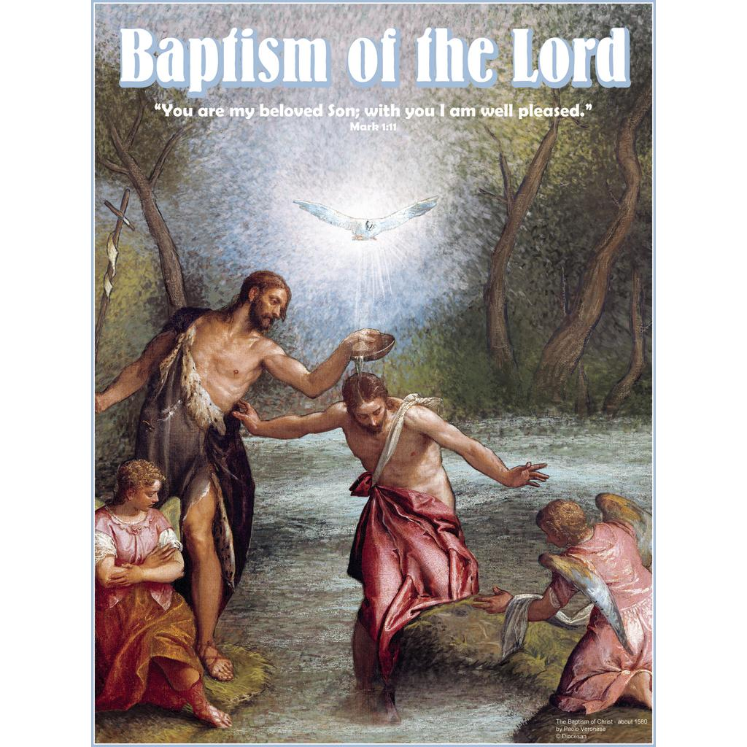
To Know Christ, To Serve Christ, To Proclaim Christ 12 JANUARY 2020

August, 2017

SENTENCE:
A voice came from heaven, saying, ‘This is my Son, the Beloved, with whom I am well pleased.’ Matthew 3.17

COLLECT: Loving God,
your Son came to seek the lost,
and was baptised with sinners: grant that we,
who have been baptised in his name,
may reach out in love to those in need
with the mercy of Christ our Lord,
who lives and reigns with you, for ever and ever. Amen.

HYMNS: TIS 231; MP465; TIS270; TIS228

FIRST READING –Isaiah 42.1-9
A reading from the book of Isaiah Chapter 42 beginning at the 1st verse:

¹ Here is my servant, whom I uphold, my chosen, in whom my soul delights; I have put my spirit upon him; he will bring forth justice to the nations.
² He will not cry or lift up his voice, or make it heard in the street;
³ a bruised reed he will not break, and a dimly burning wick he will not quench; he will faithfully bring forth justice.
⁴ He will not grow faint or be crushed until he has established justice in the earth;
and the coastlands wait for his teaching.
⁵ Thus says God, the Lord, who created the heavens and stretched them out, who spread out the earth and what comes from it who gives breath to the people upon it and spirit to those who walk in it:
⁶ I am the Lord , I have called you in righteousness, I have taken you by the hand and kept you; I have given you as a covenant to the people, a light to the nations,
⁷ to open the eyes that are blind, to bring out the prisoners from the dungeon, from the prison those who sit in darkness.
⁸ I am the Lord , that is my name; my glory I give to no other, nor my praise to idols.
⁹ See, the former things have come to pass, and new things I now declare;
before they spring forth,
Hear the word of the Lord. Thanks be to God.

PARISH NEWS, HAPPENINGS
& PRAYER POINTS – 5 JANUARY 2020

If you are visiting us today, it is wonderful you have joined us to worship the Living Lord.
If you would like to find out more about Jesus or His church here at St James, please speak to the clergy or a parishioner.

WEEKLY SERVICES
Sunday: Wednesday Morning:
8am: Holy Communion 10am Holy Comm. & Morning tea
10am Holy Comm. & Morning Tea
4:30pm Arabic speaking Congregation Friday Evening:
6pm Chollo speaking Congregation 5pm Evening Prayers - All welcome

DATES FOR YOUR DIARY:
15-18th January - 7.30PM SUTS (Syndal Baptist)

SUTS-SUMMER UNDER THE SUN – FREE EVENING SESSIONS
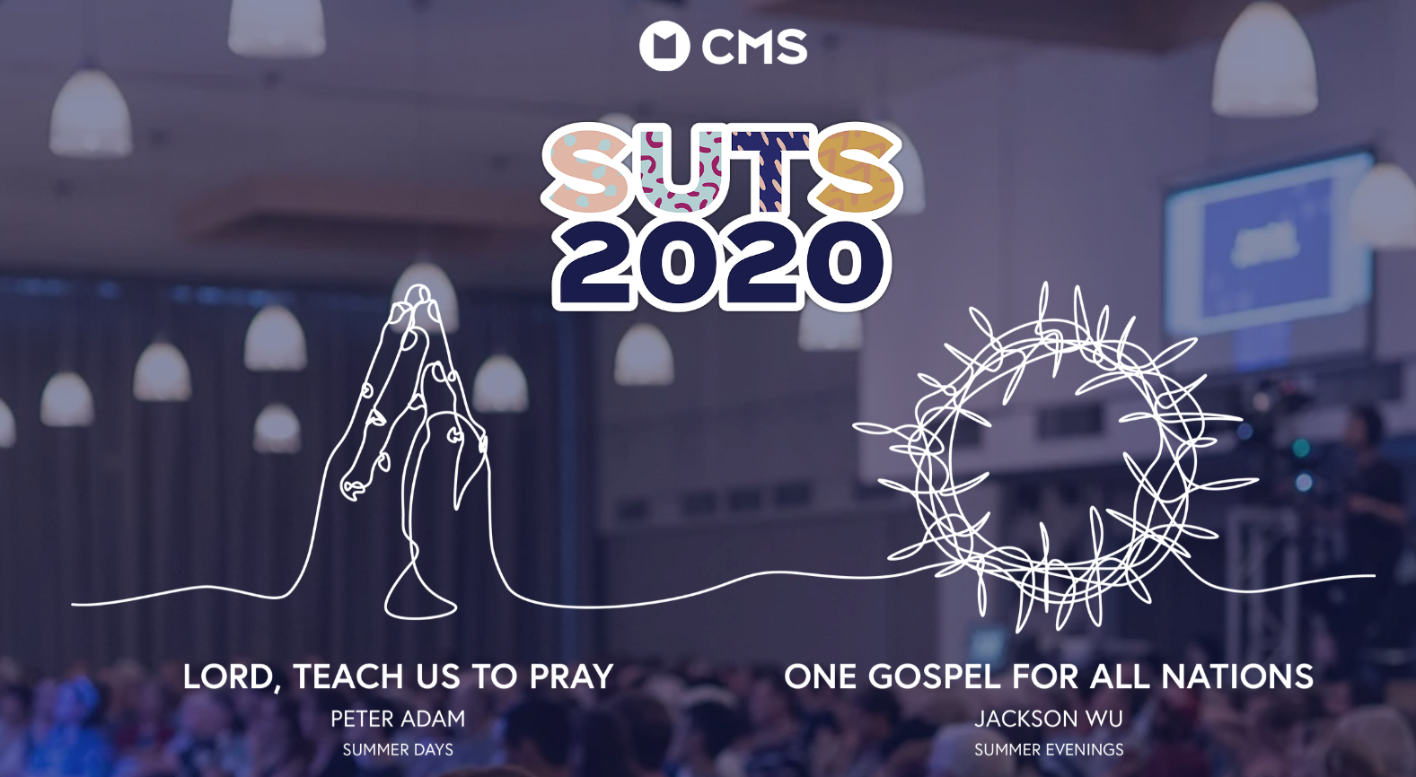

THANK YOU LUNCH - FEB 2ND 2020

A farewell lunch will be held after Rev Jeremy’s last service. A list will be available in the porch for anyone who wants to contribute towards the catering on the day. Please speak with Therese Carnie or Michael Willis if you have any questions.

NEW CURATE

I am pleased to announce that an appointment has been made for a new assistant curate for our Parish. Rev. Michael Kicevski will begin on Sunday 9th of Feb. Michael has recently completed his studies at Ridley College and will be ordained Deacon on Saturday the 8th of Feb at St Pauls Cathedral in the ordination of Deacon Service at 10:30am. It would be great to have a group from our Parish supporting Michael on this important occasion. We look forward to welcoming Michael to the ministry team of our Parish.

FROM THE ARCHIVES
February 1960

Churchwardens report

FINANCE

Although the financial position appears to be favourable when one views the annual balance sheets, it is more sobering to reflect that, disregarding expenditure on major works and long standing repairs, the surpluses of reciepts over expenditure have steadily declined over the past six years. This is due to a gradual decline in offerings and a gradual increase in expenditure. With the need for further expansion and the expense of rebuilding our organ, the Vestry has decided to engage the Diocese of Melbourne to direct a canvass of parishioners in May 1961

Although the rebuilding of our organ has been a growing necessity for more than six years, the work cannot be posponed any longer. This will be costly work, but looking ahead over a period of years the expense must be considered as a sound investment, as we have one of the finest instruments in the Diocese.

TODAY’S MESSAGE ON THE BAPTISM OF JESUS:

Is there a moment in your life when you could say that the stars aligned and everything came together and you knew what you were put on earth for?

Jesus’ baptism was one of those moments in his life, and it is one of the most important points in the gospel. It is a unique & incredibly significant point in history where:
- the heavens are opened
- the voice of God the Father booms down from heaven and
- the Spirit descends over the Son.

All three persons of the Holy Trinity are present at this special moment in history as the spheres and timeframes of heaven & earth come together. It was a key moment in Jesus ministry as the Father affirms both Jesus’ identity and mission.

To Think About:
If Jesus’ Baptism was the moment in his life when his mission and his identity became clear, when did your mission and identity moment occur in your life?

Matthew 3:13-17
The Baptism of Jesus.
Introduction: A unique point & incredibly significant point in history
- The obedience of God the Son
John was confused as to why Jesus should be baptized.
Why? To fulfil all righteousness. Matthew 3:13.
- The anointing of God the Spirit.
As Jesus came up, the Spirit came down.
The fulfilment of the prophets (Isaiah 42:1)
- The Blessing of God the Father
“You are my son whom I love”. Psalm 2:7
“With you I am well pleased” Isaiah 42:1

CLEANING ROSTER for January – Fridays @ 8am
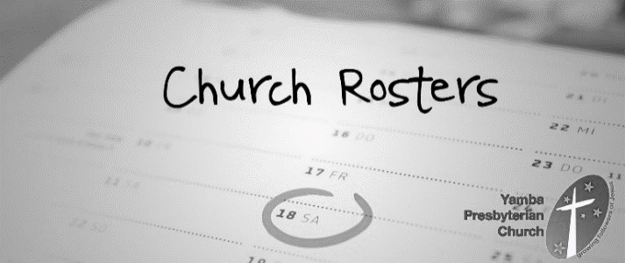
Friday 17th Jan Marien and Tyrone
Friday 24th Jan Rusty and FR Oyem
Friday 31st Jan Christine and helper please

LAWN MOWING ROSTER:
18 January: Vic Landsman & Frank Drake
25 January: Samoan Congregation

St James Offertory Giving:
November Actual: $11,120 Budgeted: $12,917
November Deficit: $1,797 Year to Date Deficit: $1,612

PLEASE REMEMBER IN YOUR PRAYERS:
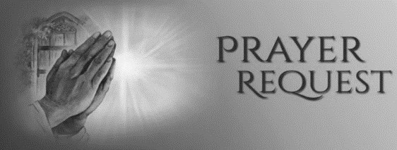
We pray for: the people and community of the parish of Charlton and Donald. Please also pray for the wonderful work of the Andrews Centre and our local Primary and Secondary Schools.

We pray for those who are sick or troubled in body or mind, or who have special needs: (Please put names in the Book for Prayers located with the Name Tags at the rear of the Church. This book is for use for prayers for anyone who is in need of them)
Mike; Jan; Antoinette; Claire; Fred; Ruth; Alma; Don; Terry; Margaret; Olive; Lucile; Mary; Jago; Emmanuel & Jeje; Brenda; Allan; Owen; Ian; Vyvyan; Noel; Melody; David; Robert; Gloria & Lew; Tammy; Janet; Sally; Trudy; Dane; Stanley; Kamie; Sherene; Suzie & Charles; Trisha; Sr Gloria, Bob; Nicole; Elise; Mazzie; Beryl; Beryl & Alan; Milton; Hazel; Renzo; Meg & John; Jonathan; Elaine; Kieran; Jason; Stephen; Mark; Helga; Judy; Maria; Fay; Judy; Kathleen.

Prayers: We pray for the; Anglican Church of Australia (Abp Philip Freier); Diocese of Bunbury (Bp Ian Coutts, Clergy & People); Converge International (Jenny George, CEO, and Chaplains); St Jude's Carlton (Samuel Oldland; Peter Greenwood; John Forsyth; Michael Phillips; Chris Porter; Alex Zunica); Primates Meeting in Amman, Jordan (Abp Dr Philip Freier); this week.

NEXT WEEK’S READINGS – 19 January
Isaiah: 49.1-7, Ps: 40.1-14, 1 Corinthians: 1.1-9, John: 1.29-42

St James’ Anglican Church Dandenong 55 Langhorne St, Dandenong 3175
Postal address: 7 Wilson St, Dandenong 3175 Parish Office 9793 0219
contact@stjamesdandenong.com www.stjamesdandenong.com
Vicar: Rev Graeme Peters 0468 696 253 gpeters@stjamesdandenong.comAsst Priest: Rev Jeremy Watson 0437 294 551 jwatson@stjamesdandenong.com
Hon. Priest: Fr George Ladu 0434 417 617 lgeorge.daniel@yahoo.com
Hon Priest: Fr Oyem Amaylek 0432 298 398 aoyem@hotmail.com
Office Assistant: Roanna Gray contact@stjamesdandenong.com
Psalm 29

¹ Ascribe to the Lord, you powers of heaven:
ascribe to the Lord glory and might.
² Ascribe to the Lord the honour due to his name:
O worship the Lord in the beauty of his holiness.
³ The voice of the Lord is upon the waters:
the God of glory thunders,
the Lord upon the great waters.
⁴ The voice of the Lord is mighty in operation:
the voice of the Lord is a glorious voice.
⁵ The voice of the Lord breaks the cedar-trees:
the Lord breaks in pieces the cedars of Lebanon.
⁶ He makes them skip like a calf:
Lebanon and Sirion like a young wild ox.
⁷ The voice of the Lord divides the lightning-flash:
the voice of the Lord whirls the sands of the desert,
the Lord whirls the desert of Kadesh.
⁸ The voice of the Lord rends the terebinth trees,
and strips bare the forests:
in his temple all cry ‘Glory.’
⁹ The Lord sits enthroned above the water-flood:
the Lord sits enthroned as a king for ever.
¹⁰ The Lord will give strength to his people:
the Lord will give to his people the blessing of peace.

SECOND READING - Acts 10.34-43
A reading from Acts Chapter 10 beginning at the 34th verse:

³⁴ Then Peter began to speak to them: ‘I truly understand that God shows no partiality, ³⁵ but in every nation anyone who fears him and does what is right is acceptable to him. ³⁶ You know the message he sent to the people of Israel, preaching peace by Jesus Christ—he is Lord of all. ³⁷ That message spread throughout Judea, beginning in Galilee after the baptism that John announced: ³⁸ how God anointed Jesus of Nazareth with the Holy Spirit and with power; how he went about doing good and healing all who were oppressed by the devil, for God was with him. ³⁹ We are witnesses to all that he did both in Judea and in Jerusalem. They put him to death by hanging him on a tree; ⁴⁰ but God raised him on the third day and allowed him to appear, ⁴¹ not to all the people but to us who were chosen by God as witnesses, and who ate and drank with him after he rose from the dead. ⁴² He commanded us to preach to the people and to testify that he is the one ordained by God as judge of the living and the dead. ⁴³ All the prophets testify about him that everyone who believes in him receives forgiveness of sins through his name.
Hear the word of the Lord, Thanks be to God.

GOSPEL READING – Matthew 3.13-17
The Gospel of our Lord Jesus Christ according to St Matthew Chapter 2 beginning at the 1st verse: Glory to you Lord Jesus Christ

¹³ Then Jesus came from Galilee to John at the Jordan, to be baptized by him. ¹⁴ John would have prevented him, saying, ‘I need to be baptized by you, and do you come to me?’ ¹⁵ But Jesus answered him, ‘Let it be so now; for it is proper for us in this way to fulfil all righteousness.’ Then he consented. ¹⁶ And when Jesus had been baptized, just as he came up from the water, suddenly the heavens were opened to him and he saw the Spirit of God descending like a dove and alighting on him. ¹⁷ And a voice from heaven said, ‘This is my Son, the Beloved, with whom I am well pleased.’
For the Gospel of the Lord Praise to you Lord Jesus Christ

