ST JAMES’ PARISH NEWS

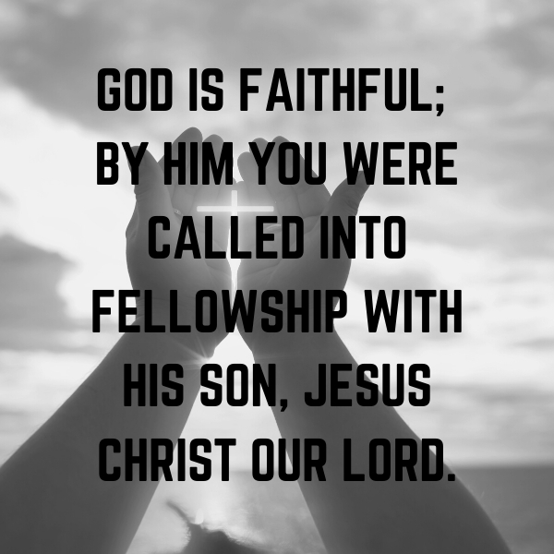

To Know Christ, To Serve Christ, To Proclaim Christ 19 JANUARY 2020

August, 2017

SENTENCE:

God is faithful; by him you were called into the fellowship of his Son, Jesus Christ our Lord. 1 Corinthians 1.9

COLLECT: Almighty God,
by whose grace alone we are accepted
and called to your service:
strengthen us by your Holy Spirit
and make us worthy of our calling;
through Jesus Christ our Lord. Amen.

HYMNS: TIS 224; MP1214; TIS560; TIS154

FIRST READING –Isaiah 49.1-7

A reading from the book of Isaiah Chapter 49 beginning at the 1st verse:

¹ Listen to me, O coastlands, pay attention, you peoples from far away! The Lord called me before I was born,
while I was in my mother’s womb he named me.
² He made my mouth like a sharp sword, in the shadow of his hand he hid me; he made me a polished arrow, in his quiver he hid me away.
³ And he said to me, ‘You are my servant, Israel, in whom I will be glorified.’
⁴ But I said, ‘I have laboured in vain, I have spent my strength for nothing and vanity; yet surely my cause is with the Lord, and my reward with my God.’
⁵ And now the Lord says, who formed me in the womb to be his servant, to bring Jacob back to him, and that Israel might be gathered to him,
for I am honoured in the sight of the Lord, and my God has become my strength—
⁶ he says, ‘It is too light a thing that you should be my servant to raise up the tribes of Jacob and to restore the survivors of Israel; I will give you as a light to the nations, that my salvation may reach to the end of the earth.’
⁷ Thus says the Lord, the Redeemer of Israel and his Holy One, to one deeply despised, abhorred by the nations, the slave of rulers,
‘Kings shall see and stand up, princes, and they shall prostrate themselves,
because of the Lord , who is faithful, the Holy One of Israel, who has chosen you’

Hear the word of the Lord. Thanks be to God.

PARISH NEWS, HAPPENINGS
& PRAYER POINTS – 19 JANUARY 2020

If you are visiting us today, it is wonderful you have joined us to worship the Living Lord.
If you would like to find out more about Jesus or His church here at St James, please speak to the clergy or a parishioner.

WEEKLY SERVICES
Sunday: Wednesday Morning:
8am: Holy Communion 10am Holy Comm. & Morning tea
10am Holy Comm. & Morning Tea
4:30pm Arabic speaking Congregation Friday Evening:
6pm Chollo speaking Congregation 5pm Evening Prayers - All welcome

DATES FOR YOUR DIARY:
2nd February Farewell Lunch for Jeremy and Sarah

THANK YOU LUNCH - FEB 2ND 2020
A farewell lunch will be held after Rev Jeremy’s last service. A list is available in the porch for anyone who wants to contribute towards the catering on the day. Please speak with Therese Carnie or Michael Willis if you have any questions.

NEW CURATE
I am pleased to announce that an appointment has been made for a new assistant curate for our Parish. Rev. Michael Kicevski will begin on Sunday 9th of Feb. Michael has recently completed his studies at Ridley College and will be ordained Deacon on Saturday the 8th of Feb at St Pauls Cathedral in the ordination of Deacon Service at 10:30am. It would be great to have a group from our Parish supporting Michael on this important occasion. We look forward to welcoming Michael to the ministry team of our Parish.

PRAYER FOR THE BUSHFIRES:

Our heavenly Father, creator of all things and especially the creator of this land and its original peoples, we call out to you in these desperate times as fires have swept across several parts of our country. Our hearts cry out to you for those who have lost loved ones, and those who have lost properties in the wake of these ravaging fires.
Father we pray, in your mercy, restrain the forces of nature from creating catastrophic damage; in your mercy protect human life. Guard those volunteers, rural fire service personnel and emergency services who selflessly step into the breach to fight these fires. Guide police and authorities who help evacuate and shelter those who are displaced. Bring comfort and healing to all who suffer loss. Remembering your promises of old that seedtime and harvest will never cease, we pray that you would open the heavens to send refreshing rain upon our parched land. In your mercy, we pray for drenching rain.
We pray that you would bring forth rain to quench these fires and to bring life back into the earth, so that crops may grow and farmers may bring forth the harvest of the land again. We bring these requests before your throne, in the name of your Son, who died and rose again for our deliverance. Amen

ANGLICAN AGENCIES YOU CAN DONATE TO FOR ASSISTING WITH BUSHFIRE RELIEF:

Bush Church Aid (BCA) Kirkby Trust
BCA people are on the ground or have a connection in directly affected areas, including Kangaroo Island, the new ministry in the Jindabyne region and also Mallacoota and Cann River. BCA has the means to provide financial resources for direct pastoral engagement and relief in the affected communities, not only for BCA areas but also for any churches or dioceses that ask for their help that is within their means to provide.
Select ‘Kirkby Trust’ for your donation: https://www.bushchurchaid.com.au/donate

Anglicare Bushfire Appeal
Donations can help provide emergency relief to people and families who have lost all of their possessions.
https://www.anglicarevic.org.au/donation/bushfireappeal/

Melbourne Anglican Foundation Trust
Bushfire emergency relief fund opened within the Diocese of Melbourne, with funds raised to be distributed to those in need in consultation with the bishops of the Victorian dioceses affected.
https://maf.melbourneanglican.org.au/userDetails

TODAY’S MESSAGE:

How does the gospel teach us to live?
Over the next five weeks, our New Testament epistle readings will be from Paul’s first letter to the Corinthians. 1 Corinthians has lots of practical relevance for daily living, covering issues of church unity, settling arguments, spiritual gifts, proper worship, marriage, divorce, singleness, sexuality and many more. But in particular, it is a book about how the gospel of the death and resurrection of Jesus Christ teaches us to live. 1 Corinthians explains the grace of God, the lordship of Christ, and the work of the Holy Spirit. It is writing to Christians who, despite their faith and identity in the Lord Jesus and his church, often live as if they still belong to the world.

Even though we live in a different time and place to the first readers of 1 Corinthians, we face the same problems today! All of us need to be reminded of who we really are: that we are called by God through Jesus Christ, that his death cleanses us, his resurrection provides new life, his ongoing power through the Spirit guides us for a new way of thinking and living.

This new way of being comes from God’s grace through Jesus, the focus of today’s passage: 1 Corinthians 1:1-9. You might feel unholy or lacking in strength, power or knowledge. But the gospel of Jesus says that God’s people are now holy/sanctified though Jesus (v.2), rich in every way, including knowledge and speech (v.5), having every spiritual gift (v.7), and will be strengthened and blameless in the end (v.8). How does God achieve this? Through our ‘Lord Jesus Christ’ (the most repeated phrase in the passage). We have confidence in this because ‘God is faithful; by him you were called into the fellowship of his Son, Jesus Christ our Lord’ (v.9). If you want to know how the gospel teaches us to live, pay attention to 1 Corinthians.

CLEANING ROSTER for January – Fridays @ 8am
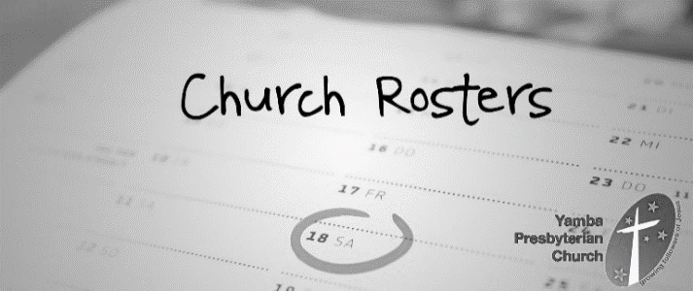
Friday 24th Jan: Rusty and FR Oyem
Friday 31st Jan: Christine and helper please

LAWN MOWING ROSTER:

25 January: Samoan Congregation
31 January: Russell Paulsen & Frank Drake

St James Offertory Giving:
November Actual: $11,120 Budgeted: $12,917
November Deficit: $1,797 Year to Date Deficit: $1,612

PLEASE REMEMBER IN YOUR PRAYERS:
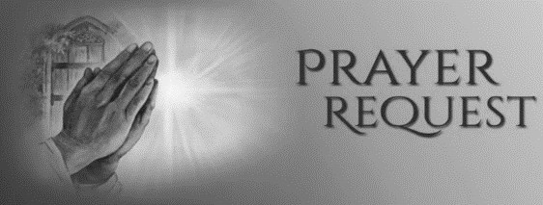
We pray for: the people and community of the parish of Charlton and Donald. Please also pray for the wonderful work of the Andrews Centre and our local Primary and Secondary Schools.

We pray for those who are sick or troubled in body or mind, or who have special needs: (Please put names in the Book for Prayers located with the Name Tags at the rear of the Church. This book is for use for prayers for anyone who is in need of them)
Mike; Jan; Antoinette; Claire; Fred; Ruth; Alma; Don; Terry; Margaret; Olive; Lucile; Mary; Jago; Emmanuel & Jeje; Brenda; Allan; Owen; Ian; Vyvyan; Noel; Melody; David; Robert; Gloria & Lew; Tammy; Janet; Sally; Trudy; Dane; Stanley; Kamie; Sherene; Suzie & Charles; Trisha; Sr Gloria, Bob; Nicole; Elise; Mazzie; Beryl; Beryl & Alan; Milton; Hazel; Renzo; Meg & John; Jonathan; Elaine; Kieran; Jason; Stephen; Mark; Helga; Judy; Maria; Fay; Judy; Kathleen.

Prayers: We pray for the; United Church of Bangladesh (The Most Revd Samuel Sunil Mankhin); Diocese of Melbourne (Abp Philip Freier, Bps Paul Barker, Bradly Billings, Genieve Blackwell, Kate Prowd, Registrar Michael Urwin, Clergy & People); Spiritual Health Victoria Council (Cheryl Holmes, CEO); Chinese Mission of the Epiphany Melbourne (Richard Liu); St Thomas’, Upper Ferntree Gully – Pastoral Service (Bp Paul Barker); this week.

NEXT WEEK’S READINGS – 26 January
Isaiah: 9.1-4, Ps: 27.1-10, 1 Corinthians: 1.10-18, Matthew 4.12-25

St James’ Anglican Church Dandenong 55 Langhorne St, Dandenong 3175
Postal address: 7 Wilson St, Dandenong 3175 Parish Office 9793 0219
contact@stjamesdandenong.com www.stjamesdandenong.com
Vicar: Rev Graeme Peters 0468 696 253 gpeters@stjamesdandenong.comAsst Priest: Rev Jeremy Watson 0437 294 551 jwatson@stjamesdandenong.com
Hon. Priest: Fr George Ladu 0434 417 617 lgeorge.daniel@yahoo.com
Hon Priest: Fr Oyem Amaylek 0432 298 398 aoyem@hotmail.com
Office Assistant: Roanna Gray contact@stjamesdandenong.com
Psalm 40.1-14

¹ I waited patiently for the Lord:
and he inclined to me and heard my cry.
² He brought me up from the pit of roaring waters,
out of the mire and clay:
and set my feet upon a rock, and made firm my foothold.
³ And he has put a new song in my mouth:
even a song of thanksgiving to our God.
⁴ Many shall see it and fear:
and shall put their trust in the Lord.
⁵ Blessed are those who have made the Lord their hope:
who have not turned to the proud,
or to those who wander in deceit.
⁶ O Lord my God, great are the wonderful things
which you have done,
and your thoughts which are towards us:
there is none to be compared with you;
⁷ Were I to declare them and speak of them:
they are more than I am able to express.
⁸ Sacrifice and offering you do not desire:
but my ears you have marked for obedience;
⁹ Burnt-offering and sin-offering you have not required:
then said I, Lo, I come.
¹⁰ In the scroll of the book it is written of me,
that I should do your will:
O my God, I long to do it, your law delights my heart.
¹¹ I have declared your righteousness
in the great congregation:
I have not restrained my lips, O Lord,
and that you know.
¹² I have not hidden your righteousness in my heart:
I have spoken of your faithfulness and of your salvation.
¹³ I have not kept back your loving-kindness and your truth:
from the great congregation.
¹⁴ O Lord, do not withhold your mercy from me:
let your loving-kindness and your truth ever preserve me.

SECOND READING - 1 Corinthians 1.1-9
A reading from 1 Corinthians Chapter 1 beginning at the 9th verse:
¹ Paul, called to be an apostle of Christ Jesus by the will of God, and our brother Sosthenes, ² To the church of God that is in Corinth, to those who are sanctified in Christ Jesus, called to be saints, together with all those who in every place call on the name of our Lord Jesus Christ, both their Lord and ours: ³ Grace to you and peace from God our Father and the Lord Jesus Christ. ⁴ I give thanks to my God always for you because of the grace of God that has been given you in Christ Jesus, ⁵ for in every way you have been enriched in him, in speech and knowledge of every kind— ⁶ just as the testimony of Christ has been strengthened among you— ⁷ so that you are not lacking in any spiritual gift as you wait for the revealing of our Lord Jesus Christ. ⁸ He will also strengthen you to the end, so that you may be blameless on the day of our Lord Jesus Christ. ⁹ God is faithful; by him you were called into the fellowship of his Son, Jesus Christ our Lord.
Hear the word of the Lord, Thanks be to God.

GOSPEL READING – John 1.29-42
The Gospel of our Lord Jesus Christ according to St John Chapter 1 beginning at the 29th verse: Glory to you Lord Jesus Christ
²⁹ The next day he saw Jesus coming towards him and declared, ‘Here is the Lamb of God who takes away the sin of the world! ³⁰ This is he of whom I said, “After me comes a man who ranks ahead of me because he was before me.” ³¹ I myself did not know him; but I came baptizing with water for this reason, that he might be revealed to Israel.’ ³² And John testified, ‘I saw the Spirit descending from heaven like a dove, and it remained on him. ³³ I myself did not know him, but the one who sent me to baptize with water said to me, “He on whom you see the Spirit descend and remain is the one who baptizes with the Holy Spirit.” ³⁴ And I myself have seen and have testified that this is the Son of God.’ ³⁵ The next day John again was standing with two of his disciples, ³⁶ and as he watched Jesus walk by, he exclaimed, ‘Look, here is the Lamb of God!’ ³⁷ The two disciples heard him say this, and they followed Jesus. ³⁸ When Jesus turned and saw them following, he said to them, ‘What are you looking for?’ They said to him, ‘Rabbi’ (which translated means Teacher), ‘where are you staying?’ ³⁹ He said to them, ‘Come and see.’ They came and saw where he was staying, and they remained with him that day. It was about four o’clock in the afternoon. ⁴⁰ One of the two who heard John speak and followed him was Andrew, Simon Peter’s brother. ⁴¹ He first found his brother Simon and said to him, ‘We have found the Messiah’ (which is translated Anointed). ⁴² He brought Simon to Jesus, who looked at him and said, ‘You are Simon son of John. You are to be called Cephas’ (which is translated Peter).
For the Gospel of the Lord Praise to you Lord Jesus Christ

